**SHRI DATTA MEGHE POLYTECHNIC, NAGPUR**

**DEPARTMENT OF COMPUTER TECHNOLOGY**

**SESSION 2019-2020**



**Report of Micro Project for the Subject Mobile Application Development (22617)**

On

**Developing an Android Game – Tic Tac Toe**

Submitted By

#### **1. Amaan Ranapurwala 2. Aniruddha Kate**

#### **3. Dewam Katole 4. Ritvik Nimje**

Group No. 4

Sixth Semester

COMPUTER TECHNOLOGY

*Guide*

Mr S.Taley

Program:-

1. **activity_main.xml**

<?xml version="1.0" encoding="utf-8"?>  
<LinearLayout xmlns:android="http://schemas.android.com/apk/res/android"  
 xmlns:app="http://schemas.android.com/apk/res-auto"  
 xmlns:tools="http://schemas.android.com/tools"  
 android:layout_width="match_parent"  
 android:layout_height="match_parent"  
 android:orientation="vertical"  
 tools:context=".MainActivity">  
  
  
 <RelativeLayout  
 android:layout_width="match_parent"  
 android:layout_height="wrap_content">  
 <TextView  
 android:id="@+id/text_view_p1"  
 android:layout_width="wrap_content"  
 android:layout_height="wrap_content"  
 android:text="Player 1: 0"  
 android:textSize="30sp"  
 android:freezesText="true">  
 </TextView>  
  
 <TextView  
 android:id="@+id/text_view_p2"  
 android:layout_width="wrap_content"  
 android:layout_height="wrap_content"  
 android:layout_below="@+id/text_view_p1"  
 android:text="Player 2: 0"  
 android:textSize="30sp"  
 android:freezesText="true">  
 </TextView>  
  
 <Button  
 android:id="@+id/button_reset"  
 android:layout_width="wrap_content"  
 android:layout_height="wrap_content"  
 android:layout_alignParentRight="true"  
 android:layout_marginRight="20dp"  
 android:text="reset"  
 android:freezesText="true">  
  
 </Button>  
  
 </RelativeLayout>  
   
 <LinearLayout  
 android:layout_width="match_parent"  
 android:layout_height="0dp"  
 android:layout_weight="1">  
  
 <Button  
 android:id="@+id/button_00"  
 android:layout_width="0dp"  
 android:layout_height="match_parent"  
 android:layout_weight="1"  
 android:textSize="60sp"  
 android:freezesText="true">  
  
 </Button>  
  
 <Button  
 android:id="@+id/button_01"  
 android:layout_width="0dp"  
 android:layout_height="match_parent"  
 android:layout_weight="1"  
 android:textSize="60sp"  
 android:freezesText="true">  
  
 </Button>  
  
 <Button  
 android:id="@+id/button_02"  
 android:layout_width="0dp"  
 android:layout_height="match_parent"  
 android:layout_weight="1"  
 android:textSize="60sp"  
 android:freezesText="true">  
  
 </Button>  
  
 </LinearLayout>  
  
 <LinearLayout  
 android:layout_width="match_parent"  
 android:layout_height="0dp"  
 android:layout_weight="1">  
  
 <Button  
 android:id="@+id/button_10"  
 android:layout_width="0dp"  
 android:layout_height="match_parent"  
 android:layout_weight="1"  
 android:textSize="60sp"  
 android:freezesText="true">  
  
 </Button>  
  
 <Button  
 android:id="@+id/button_11"  
 android:layout_width="0dp"  
 android:layout_height="match_parent"  
 android:layout_weight="1"  
 android:textSize="60sp"  
 android:freezesText="true">  
  
 </Button>  
  
 <Button  
 android:id="@+id/button_12"  
 android:layout_width="0dp"  
 android:layout_height="match_parent"  
 android:layout_weight="1"  
 android:textSize="60sp"  
 android:freezesText="true">  
 </Button>  
  
 </LinearLayout>  
  
 <LinearLayout  
 android:layout_width="match_parent"  
 android:layout_height="0dp"  
 android:layout_weight="1">  
  
 <Button  
 android:id="@+id/button_20"  
 android:layout_width="0dp"  
 android:layout_height="match_parent"  
 android:layout_weight="1"  
 android:textSize="60sp"  
 android:freezesText="true">  
  
 </Button>  
  
 <Button  
 android:id="@+id/button_21"  
 android:layout_width="0dp"  
 android:layout_height="match_parent"  
 android:layout_weight="1"  
 android:textSize="60sp"  
 android:freezesText="true">  
  
 </Button>  
  
 <Button  
 android:id="@+id/button_22"  
 android:layout_width="0dp"  
 android:layout_height="match_parent"  
 android:layout_weight="1"  
 android:textSize="60sp"  
 android:freezesText="true">  
  
 </Button>  
  
 </LinearLayout>  
  
  
</LinearLayout>

**2) MainActivity.java**

package com.example.tictactoe;  
  
import androidx.appcompat.app.AppCompatActivity;  
import android.os.Bundle;  
import android.view.View;  
import android.widget.Button;  
import android.widget.TextView;  
import android.widget.Toast;  
  
 public class MainActivity extends AppCompatActivity implements View.OnClickListener {  
  
 private Button[][] buttons = new Button[3][3];  
  
 private boolean player1Turn = true;  
  
 private int roundCount;  
  
 private int player1Points;  
 private int player2Points;  
  
 private TextView textViewPlayer1;  
 private TextView textViewPlayer2;  
  
 @Override  
 protected void onCreate(Bundle savedInstanceState) {  
 super.onCreate(savedInstanceState);  
 setContentView(R.layout.*activity_main*);  
  
 textViewPlayer1 = findViewById(R.id.*text_view_p1*);  
 textViewPlayer2 = findViewById(R.id.*text_view_p2*);  
  
 for (int i = 0; i < 3; i++) {  
 for (int j = 0; j < 3; j++) {  
 String buttonID = "button_" + i + j;  
 int resID = getResources().getIdentifier(buttonID, "id", getPackageName());  
 buttons[i][j] = findViewById(resID);  
 buttons[i][j].setOnClickListener(this);  
 }  
 }  
  
 Button buttonReset = findViewById(R.id.*button_reset*);  
 buttonReset.setOnClickListener(new View.OnClickListener() {  
 @Override  
 public void onClick(View v) {  
 resetGame();  
 }  
 });  
 }  
  
 @Override  
 public void onClick(View v) {  
 if (!((Button) v).getText().toString().equals("")) {  
 return;  
 }  
  
 if (player1Turn) {  
 ((Button) v).setText("X");  
 } else {  
 ((Button) v).setText("O");  
 }  
  
 roundCount++;  
  
 if (checkForWin()) {  
 if (player1Turn) {  
 player1Wins();  
 } else {  
 player2Wins();  
 }  
 } else if (roundCount == 9) {  
 draw();  
 } else {  
 player1Turn = !player1Turn;  
 }  
  
 }  
  
 private boolean checkForWin() {  
 String[][] field = new String[3][3];  
  
 for (int i = 0; i < 3; i++) {  
 for (int j = 0; j < 3; j++) {  
 field[i][j] = buttons[i][j].getText().toString();  
 }  
 }  
  
 for (int i = 0; i < 3; i++) {  
 if (field[i][0].equals(field[i][1])  
 && field[i][0].equals(field[i][2])  
 && !field[i][0].equals("")) {  
 return true;  
 }  
 }  
  
 for (int i = 0; i < 3; i++) {  
 if (field[0][i].equals(field[1][i])  
 && field[0][i].equals(field[2][i])  
 && !field[0][i].equals("")) {  
 return true;  
 }  
 }  
  
 if (field[0][0].equals(field[1][1])  
 && field[0][0].equals(field[2][2])  
 && !field[0][0].equals("")) {  
 return true;  
 }  
  
 if (field[0][2].equals(field[1][1])  
 && field[0][2].equals(field[2][0])  
 && !field[0][2].equals("")) {  
 return true;  
 }  
  
 return false;  
 }  
  
 private void player1Wins() {  
 player1Points++;  
 Toast.*makeText*(this, "Player 1 wins!", Toast.*LENGTH_SHORT*).show();  
 updatePointsText();  
 resetBoard();  
 }  
  
 private void player2Wins() {  
 player2Points++;  
 Toast.*makeText*(this, "Player 2 wins!", Toast.*LENGTH_SHORT*).show();  
 updatePointsText();  
 resetBoard();  
 }  
  
 private void draw() {  
 Toast.*makeText*(this, "Draw!", Toast.*LENGTH_SHORT*).show();  
 resetBoard();  
 }  
  
 private void updatePointsText() {  
 textViewPlayer1.setText("Player 1: " + player1Points);  
 textViewPlayer2.setText("Player 2: " + player2Points);  
 }  
  
 private void resetBoard() {  
 for (int i = 0; i < 3; i++) {  
 for (int j = 0; j < 3; j++) {  
 buttons[i][j].setText("");  
 }  
 }  
  
 roundCount = 0;  
 player1Turn = true;  
 }  
  
 private void resetGame() {  
 player1Points = 0;  
 player2Points = 0;  
 updatePointsText();  
 resetBoard();  
 }  
  
 @Override  
 protected void onSaveInstanceState(Bundle outState) {  
 super.onSaveInstanceState(outState);  
  
 outState.putInt("roundCount", roundCount);  
 outState.putInt("player1Points", player1Points);  
 outState.putInt("player2Points", player2Points);  
 outState.putBoolean("player1Turn", player1Turn);  
 }  
  
 @Override  
 protected void onRestoreInstanceState(Bundle savedInstanceState) {  
 super.onRestoreInstanceState(savedInstanceState);  
  
 roundCount = savedInstanceState.getInt("roundCount");  
 player1Points = savedInstanceState.getInt("player1Points");  
 player2Points = savedInstanceState.getInt("player2Points");  
 player1Turn = savedInstanceState.getBoolean("player1Turn");  
 }  
 }

Output:-

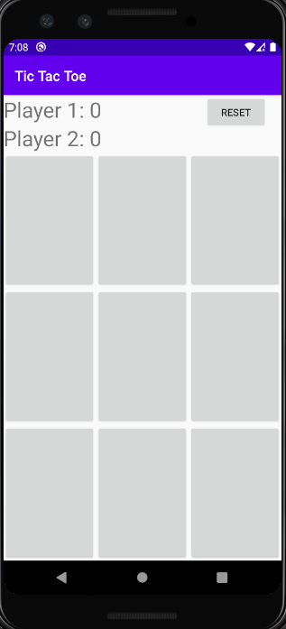 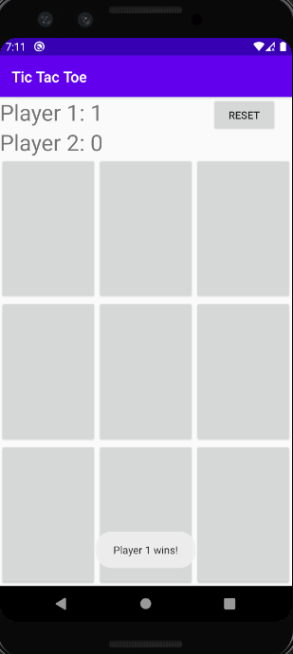

Fig.1) UI Design Fig.2) Case 1 :-

Player 1 Wins

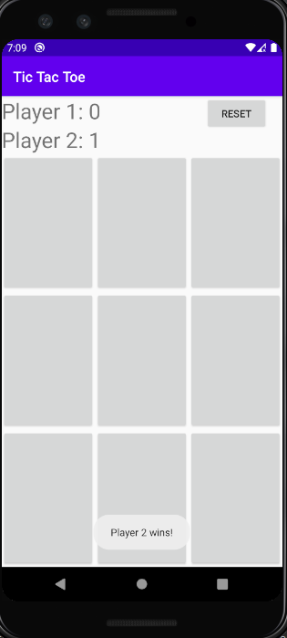 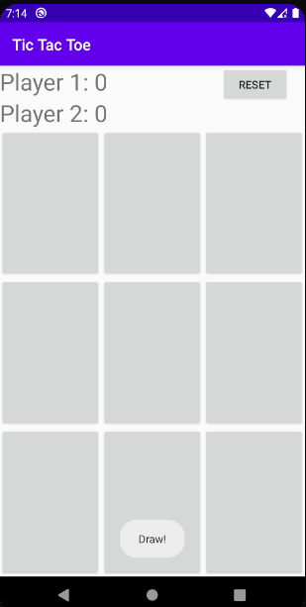

Fig.3) Case 2:- Fig.4) Case 3:-

Player 2 Wins Draw

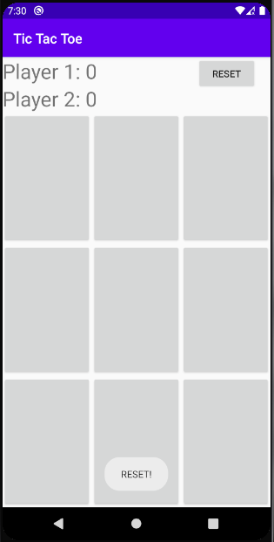

Fig.5) Case 4:-

Reset